Filling in the BARC stripes

First, change the 0 (zero) values to NULL so they can be teased out in the next step.
ArcToolbox SpatialAnalyst Tools Conditional Set Null
Since the values in the stripes equal 0, use the Expression box to change only those cells to NULL.
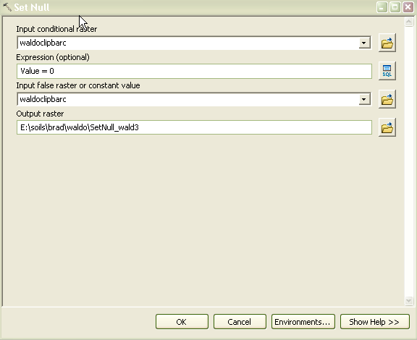

Next, execute a statement in the Raster Calculator that creates the final output.
ArcToolbox Map Algebra Raster Calculator
I’ll try to explain what the gobbledegook in the center box is doing.
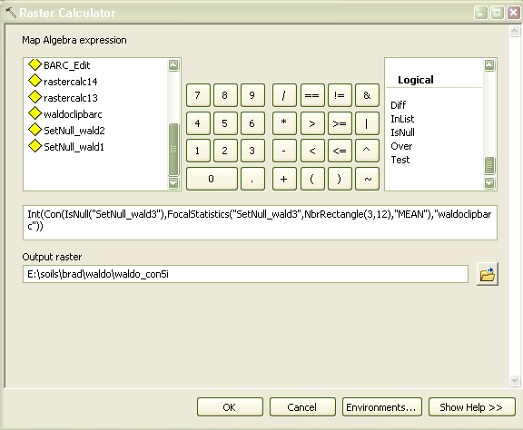

You are asking the program to look at the raster you created in step 1 and, under the condition that a cell in the raster is NULL, run statistics to calculate the mean of the non-NULL values in a 3 x12 cell rectangle and fill the NULL cells with those mean values. If the cell is not NULL, just use the original cell value in the output. Integerize the entire result so you don’t end up with floating point cell values.
It’s tricky to get the syntax typed correctly. I read a few things that indicated that the commands (Int, Con, IsNull, FocalStatistics) are case-sensitive.
I think it would be great to automate this so you don’t have to type it in every time.

