2012 Salt Creek Fire
Shasta-Trinity NF, CA
BARC_SBS metadata (from the soils report):
Soil burn severity was assessed following principles described in Parsons et al., 2010. Burned Area Reflectance Classification (BARC) imagery from the Remote Sensing Applications Center (RSAC) in Salt Lake City, UT was utilized by the soil scientist, and modified to better reflect actual soil burn severity as observed in the field. Subsequent watershed response modeling efforts use the soil burn severity map as a key input. SBS is summarized in table 2 and displayed spatially in appendix map 2.
[Small fire, so report is extremely brief. It was systematically modified, no locational or custom edits]
BARC modifications by David Young, North Zone Soil Scientist, R5, daveyoung@fs.fed.us
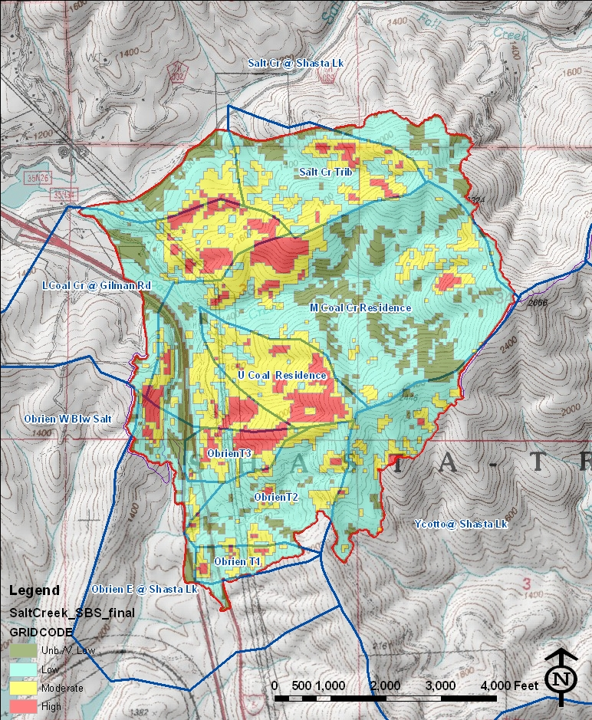
Map 2 – Soil Burn Severity Map. Refer to table 2 for acreage summary by sub-watershed.

